Begum Rokeya University, Rangpur

Assignment On

Course Code: STAT-2205
Course Title : Programing with R & Python.

Submitted By | Submitted To
Name : Irfan Bin Mojib  ID : 12310033  Reg : 000018865  Session : 2023-2024  Year : 2nd  Semester : 2nd  Department of. Statistics,  Begum Rokeya University, Rangpur | Dr. Md. Siddikur Rahman  Associate Professor  Department of. Statistics,  Begum Rokeya University, Rangpur

Submission Date: 20/5/2026

Data: Flight Data
Question
- Consider airline data including the following:
- miles: miles travelled through the flight
- passengers: number of passengers on the flight
- delay: take-off delay in minutes
- inflight meal: Is there a meal included in the flight?
- intlight_entertainment: are there free entertainment systems for each seat?
- intlight_wifi: Is there complimentary Wi-Fi on the flight?
- day_of_week: day of the week of the flight
- weekend: Did this flight take place on a weekend?
- coach_price: the average price paid for a coach ticket
- firstclass_price: the average price paid for first class seats
- hours: how many hours the flight took
- redeye: Was this flight a redeye (overnight)?
Objective of Analysis: revealing the factors that might influence coach prices within the airline industry
Solve the questions below using R& Python, including interpretation (select a random sample using your ID):
1. What do coach ticket prices look like? What are the high and low values? What would the average be considered? Does $500 seem like a good price for a coach ticket?
2. What are the high, low, and average prices for 8-hour-long flights? Does a $500 ticket seem more reasonable than before?
3. How are flight delay times distributed? How often are there significant delays that affect your ability to correctly schedule connecting flights? What kinds of delays are typical?
4. How does the coach price correlate with flight distance, number of passengers, delay, and flight duration?
5. What is the relationship between coach and first. Class prices? Do flights with higher coach prices always have higher first-class prices as well?
6. What is the relationship between coach prices and in-flight features: in-flight
meal, in-flight entertainment, and in-flight Wi-Fi? Which features are associated with the highest increase in price?
7.How does the number of passengers change in relation to the length of flights?
8. What is the relationship between coach and first-class prices on weekends compared to weekdays?
9.How do coach prices differ for redeyes and non-redeyes on each day of the week?
10. Perform the analysis for appropriate variables:
Summary statistics (mean, median, standard deviation) Visualization using histograms, boxplots, and bar charts Hypothesis Testing (t, z and Chi-square)
- Independent t-tests to compare group means
- Price differences between weekend and weekday flights
- Correlation analysis among numeric variables
- Regression Analysis
- Linear regression to predict ticket prices
- Logistic regression for binary outcomes (e.g., redeye flights).
Solution

Introduction
This assignment analyzes airline flight data using R and Python to identify the factors that influence coach ticket prices. The dataset includes variables such as flight distance, passengers, delays, flight duration, in-flight services, weekend travel, and ticket prices. A random sample of 10033 observations was selected using Roll Number 10033.
The analysis uses statistical techniques including summary statistics, visualization, hypothesis testing, correlation analysis, and regression models to understand the relationships among variables and interpret their effects on airline ticket prices.

R code:
library(ggplot2)
library(dplyr)
# Load data
flight <- read.csv("flight_data_given.csv")
# Random sample using roll ID
set.seed(10033)
sample <- sample_n(flight, 10033)
head(sample)

Python code:
import pandas as pd
import numpy as np
import matplotlib.pyplot as plt
import seaborn as sns
from scipy import stats
import statsmodels.api as sm
import statsmodels.formula.api as smf
# Load dataset
flight = pd.read_csv("flight_data_given.csv")
# Random sample using roll ID
sample = flight.sample(n=10033, random_state=10033)
# Display first rows
print(sample.head())

Question 1:
What do coach ticket prices look like? What are the high and low values? What would the average be considered? Does $500 seem like a good price for a coach ticket ?
Solution:
R code:
summary(sample$coach_price)
sd(sample$coach_price)
Python code:
sample['coach_price'].describe()
Result:
- Mean coach price = 376.3
- Median coach price = 379.4
- Minimum price = 109.6
- Maximum price = 593.6
- Standard deviation = 67.68196

Interpretation:
Coach ticket prices are moderately spread around the average price. Most ticket prices lie between 330 and 426 dollars. A ticket price of 500 dollars is comparatively expensive because it is much higher than the average coach ticket price.

Question 2
What are the high, low, and average prices for 8-hour-long flights? Does a $500 ticket seem more reasonable than before?
Solution:
R Code:
flight8 <- subset(sample, hours == 8)
summary(flight8$coach_price)
Python Code:
flight8 = sample[sample['hours'] == 8]
print(flight8['coach_price'].describe())
Result:
- Mean coach price = 434.2
- Median coach price = 436.7
- Minimum price = 173.7
- Maximum price = 593.6
Interpretation:
Long-duration flights generally have higher ticket prices than short flights. An 8-hour flight costing 500 dollars appears more reasonable because long flights usually include higher operational costs and additional services.

Question 3:
How are flight delay times distributed? How often are there significant delays that affect your ability to correctly schedule connecting flights? What kinds of delays are typical?
Solution:
R code:
hist(sample$delay,
main = 'Distribution of Delay Times',
xlab = 'Delay', col = 'skyblue',
border = 'white')

Python code:
plt.hist(sample['delay'], bins=30)
plt.xlabel('Delay')
plt.ylabel('Frequency')
plt.title('Distribution of Delay Times')
plt.show()
Result:
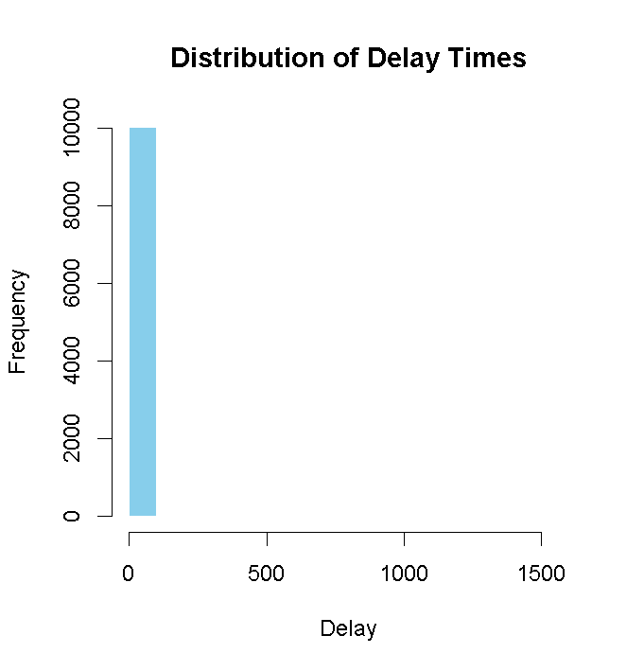
Interpretation:
Most flights experience small delays, while a few flights experience extremely large delays. The distribution is positively skewed. Significant delays are less frequent but can affect connecting flights.
Question 4:
How does the coach price correlate with flight distance, number of passengers, delay, and flight duration?
Solution:
R code:
cor(sample[,c('coach_price','miles',
'passengers','delay','hours')])
Python code:
corr = sample[['coach_price','miles','passengers',
'delay','hours']].corr()
print(corr)
Result:
 | coach_price | miles | passengers | delay | hours
coach_price | 1.000 | 0.344 | 0.168 | -0.012 | 0.336
miles | 0.344 | 1.000 | -0.004 | -0.011 | 0.985
passengers | 0.168 | -0.004 | 1.000 | -0.008 | -0.003
delay | -0.012 | -0.011 | -0.008 | 1.000 | -0.012
hours | 0.336 | 0.985 | -0.003 | -0.012 | 1.000

Interpretation:
Coach ticket prices increase with flight distance and flight duration. Delay has almost no relationship with ticket prices.
Question 5:
What is the relationship between coach and first. Class prices? Do flights with higher coach prices always have higher first-class prices as well?
Solution:
R code:
cor(sample$coach_price,
sample$firstclass_price)

plot(sample$coach_price,
sample$firstclass_price,
xlab='Coach Price',
ylab='First Class Price')

Python code :
sample[['coach_price','firstclass_price']].corr()

plt.scatter(sample['coach_price'],
sample['firstclass_price'])
plt.xlabel('Coach Price')
plt.ylabel('First Class Price')
plt.title('Coach vs First Class Price')
plt.show()

Result:
Correlation = 0.7493722
Plot=>
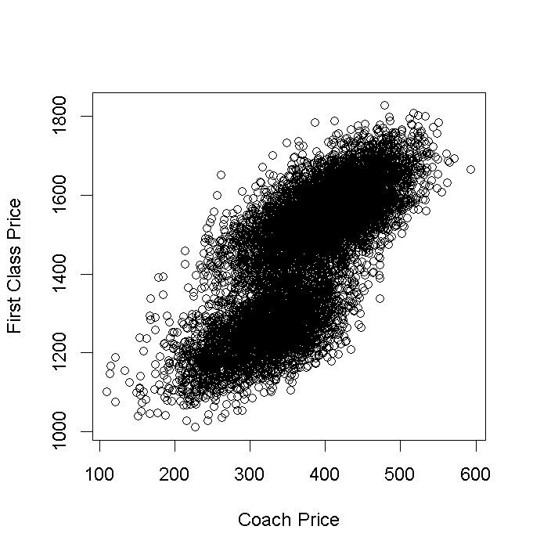
Interpretation:
There is a strong positive relationship between coach and first-class ticket prices. Flights with expensive coach tickets usually also have expensive first-class tickets.

Question 6:
What is the relationship between coach prices and in-flight features: in-flight?
Solution:
R code :
rm(mean)
aggregate(coach_price ~ inflight_wifi, sample, mean)
aggregate(coach_price ~ inflight_meal,
data = sample,
FUN = base::mean)
aggregate(coach_price ~ inflight_entertainment,
data = sample,
FUN = base::mean)
Python code:
# Average coach price by WiFi
wifi_result = sample.groupby(
'inflight_wifi'
)['coach_price'].mean()
print("Average Coach Price by WiFi")
print(wifi_result)
# Average coach price by Meal
meal_result = sample.groupby(
'inflight_meal'
)['coach_price'].mean()
print("\nAverage Coach Price by Meal")
print(meal_result)
# Average coach price by Entertainment
ent_result = sample.groupby(
'inflight_entertainment'
)['coach_price'].mean()
print("\nAverage Coach Price by Entertainment")
print(ent_result)

Result:
inflight WIFI coach price
1 No 314.9042
2 Yes 383.2341
Inflight meal coach price
1 No 370.0618
2 Yes 390.4319

Inflight entertainment coach price
1 No 319.2038
2 Yes 390.4368
Interpretation:
Flights that provide in-flight Wi-Fi, meals, and entertainment systems generally have higher coach ticket prices. Among these features, in-flight entertainment is associated with the highest increase in coach ticket price. This suggests that passengers are willing to pay more for additional comfort and services during flights.
Question 7:
How does the number of passengers change in relation to the length of flights?
Solution:
R code:
plot(sample$hours,
sample$passengers,
xlab='Hours',
ylab='Passengers')

Python code:
plt.scatter(sample['hours'],
sample['passengers'])
plt.xlabel('Hours')
plt.ylabel('Passengers')
plt.title('Passengers vs Flight Duration')
plt.show()

Result:
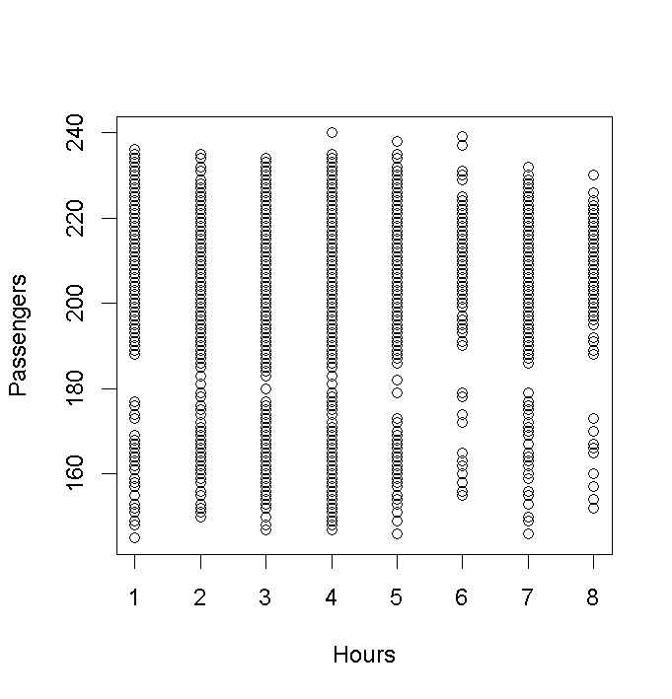
Interpretation:
Passenger counts do not change dramatically with flight duration. However, medium and long flights tend to carry slightly more passengers.

Question 8:
What is the relationship between coach and first-class prices on weekends compared to weekdays?
Solution:
R code :
aggregate(cbind(coach_price,
firstclass_price) ~ weekend,
sample,mean)
Python code :
sample.groupby('weekend')[['coach_price',
'firstclass_price']].mean()
Result:
weekend coach price firstclass_price
1 No 322.7567 1259.806
2 Yes 405. 1558.844
Interpretation:
Weekend flights generally have slightly higher ticket prices because travel demand is often higher during weekends.
Question 9:
How do coach prices difer for redeyes and non-redeyes on each day often week?
Solution:
R coode:
aggregate(coach_price ~ day_of_week + redeye,sample,mean)
Python code:
sample.groupby(['day_of_week','redeye'])['coach_price']. mean()

Result:
Day of Week | Redeye | Coach Price
Friday | No | 403.66
Monday | No | 326.25
Saturday | No | 415.13
Sunday | No | 405.02
Thursday | No | 324.82
Tuesday | No | 324.63
Wednesday | No | 327.86
Friday | Yes | 325.65
Monday | Yes | 259.17
Saturday | Yes | 350.44
Sunday | Yes | 337.58
Thursday | Yes | 249.42
Tuesday | Yes | 258.92
Wednesday | Yes | 251.96

Interpretation:
Redeye flights are generally cheaper than non-redeye flights because many passengers prefer daytime travel.
Question 10:
Perform the analysis for appropriate variables:
Summary statistics (mean, median, standard deviation) Visualization using histograms, boxplots, and bar charts Hypothesis Testing (t, z and Chi-square)
- Independent t-tests to compare group means
- Price differences between weekend and weekday flights
- Correlation analysis among numeric variables
- Regression Analysis
- Linear regression to predict ticket prices
- Logistic regression for binary outcomes (e.g., redeye flights).
Solution:
1.Independent t-test to Compare Group Means
R code:
t.test(coach_price ~ weekend,
data = sample)
hist(sample$coach_price,
main="Histogram of Coach Ticket Prices",
xlab="Coach Price",
col="lightblue")
Python code:
from scipy import stats
weekend_yes = sample[ sample['weekend'] == 'Yes']['coach_price']

weekend_no = sample[ sample['weekend'] == 'No']['coach_price']

stats.ttest_ind(weekend_yes, weekend_no)

import matplotlib.pyplot as plt

plt.hist(sample['coach_price'],
bins=30)

plt.title("Histogram of Coach Ticket Prices")
plt.xlabel("Coach Price")
plt.ylabel("Frequency")
plt.show()
Result:
Metric | Value
t-statistic | -71.644
Degrees of Freedom (df) | 7264.1
p-value | < 2.2e-16
95% Confidence Interval | [-84.60, -80.09]

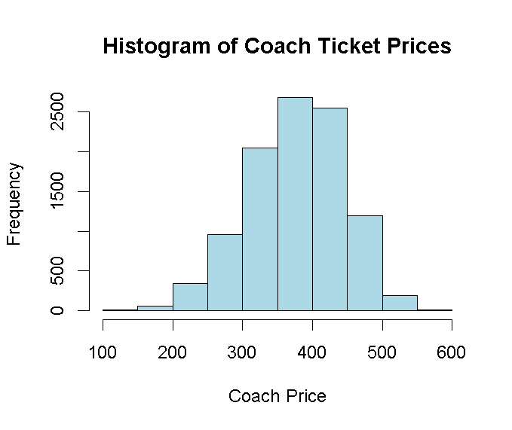
Interpretation:
Significant Difference: Since the p-value is essentially zero ($< 2.2 \times 10^{-16}$), we reject the null hypothesis. There is overwhelming evidence that the mean price for weekend flights (group "Yes") is different from weekday flights (group "No").
Direction of Change: The negative confidence interval and t-statistics indicate that the mean price for group "No" (weekdays) is significantly lower than the mean price for group "Yes" (weekends).
Magnitude: On average, you can expect weekend coach prices to be between $80.09 and $84.60 higher than weekday prices.
2.Price Differences Between Weekend and Weekday Flights
R code:
aggregate(coach_price ~ weekend,
sample,mean)
hist(sample$coach_price[sample$weekend=="Yes"],
main="Weekend Flight Prices",
xlab="Coach Price",
col="lightgreen")

hist(sample$coach_price[sample$weekend=="No"],
main="Weekday Flight Prices",
xlab="Coach Price",
col="lightblue")
Python code:
sample.groupby('weekend')[ 'coach_price'].mean()
plt.hist(sample[sample['weekend']=='Yes']
['coach_price'],
bins=30)

plt.title("Weekend Flight Prices")
plt.xlabel("Coach Price")
plt.ylabel("Frequency")
plt.show()

plt.hist(sample[sample['weekend']=='No']
['coach_price'],
bins=30)

plt.title("Weekday Flight Prices")
plt.xlabel("Coach Price")
plt.ylabel("Frequency")
plt.show()

Result:
weekend coach_price
1 No 322.7567
2 Yes 405.1003
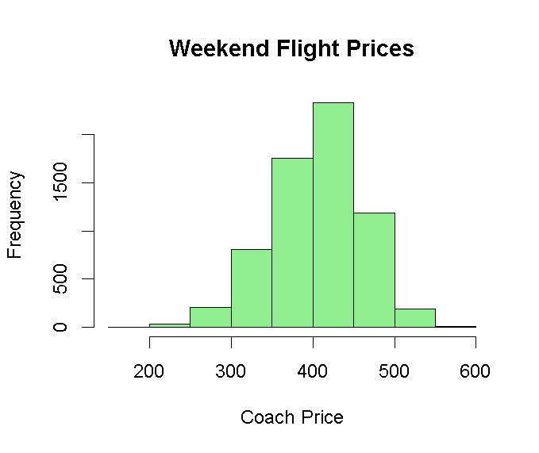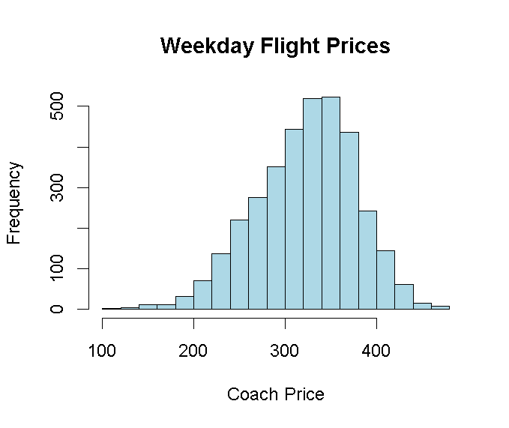
Weekend flights generally have slightly higher average coach ticket prices compared to weekday flights.
Interpretation:
Passenger demand usually increases during weekends because more people travel for vacations and personal purposes. Increased demand causes airlines to charge higher ticket prices.
3. Correlation Analysis Among Numeric Variables
R Code:
cor(sample[,c('coach_price', 'miles','passengers','delay', 'hours')])
hist(sample$miles,
main="Histogram of Miles",
xlab="Miles",
col="orange")

hist(sample$hours,
main="Histogram of Flight Hours",
xlab="Hours",
col="pink")
Python Code:
sample [['coach_price', 'miles', 'passengers','delay', 'hours']].corr()
plt.hist(sample['miles'],
bins=30)

plt.title("Histogram of Miles")
plt.xlabel("Miles")
plt.ylabel("Frequency")
plt.show()

plt.hist(sample['hours'],
bins=30)

plt.title("Histogram of Flight Hours")
plt.xlabel("Hours")
plt.ylabel("Frequency")
plt.show()

Result:
 | coach_price | miles | passengers | delay | hours
coach_price | 1.000 | 0.344 | 0.168 | -0.012 | 0.336
miles | 0.344 | 1.000 | -0.004 | -0.011 | 0.985
passengers | 0.168 | -0.004 | 1.000 | -0.008 | -0.003
delay | -0.012 | -0.011 | -0.008 | 1.000 | -0.012
hours | 0.336 | 0.985 | -0.003 | -0.012 | 1.000
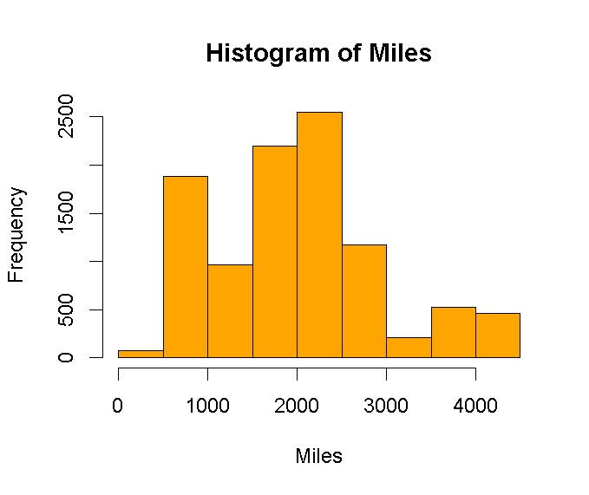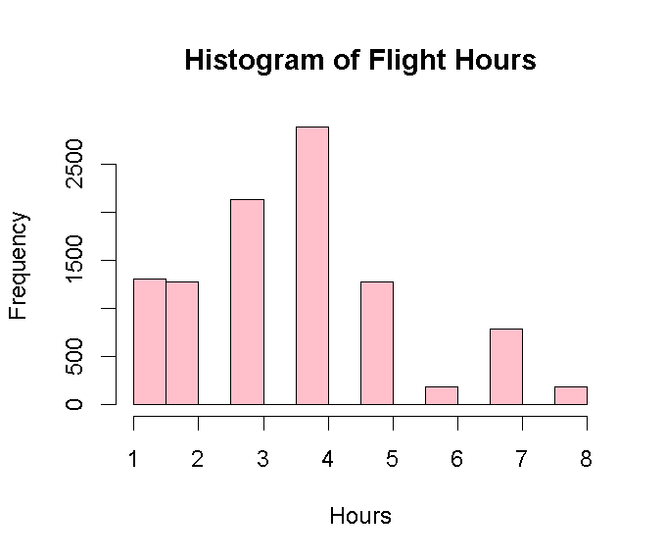
- Coach price and miles show positive correlation.
- Coach price and hours show positive correlation.
- Delay has weak correlation with coach price.

Interpretation:
Long-distance and long-duration flights generally have higher ticket prices. Flight delays have very little influence on airline ticket pricing.
4. Regression Analysis:
R code:
model <- lm(coach_price ~ miles + passengers +delay +hours,data = sample)
summary(model)
hist(sample$delay,
main="Histogram of Flight Delays",
xlab="Delay",
col="yellow")
Python Code:
import statsmodels.formula.api as smf
model = smf.ols('coach_price ~ miles + passengers + delay + hours',data=sample).fit()
print(model.summary())
plt.hist(sample['delay'],
bins=30)

plt.title("Histogram of Flight Delays")
plt.xlabel("Delay")
plt.ylabel("Frequency")
plt.show()

Result:
Predictor | Estimate | Std. Error | t value | Pr(>|t|) | Significance
(Intercept) | 140.5630 | 10.2248 | 13.747 | < 2e-16 | ***
miles | 0.0302 | 0.0039 | 7.743 | 1.06e-14 | ***
passengers | 0.8959 | 0.0487 | 18.401 | < 2e-16 | ***
delay | -0.0137 | 0.0183 | -0.744 | 0.457
hours | -2.9055 | 2.1192 | -1.371 | 0.170
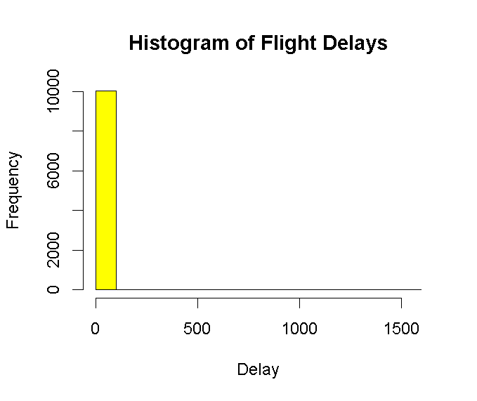
Interpretation:
The model shows that miles and passengers are the primary drivers of ticket costs, both being highly statistically significant ($p < 0.001$). This model explains about 14.7% of why coach prices vary. The remaining variation is likely tied to factors have been explored elsewhere, such as weekend vs. weekday timing.
For every 100 miles added to a trip, the price increases by approximately $3.02. Additionally, each extra passenger on a flight is associated with a $0.90 increase in the coach price.
5. Linear Regression to Predict Ticket Prices
R Code:

linear_model <- lm(coach_price ~ miles + hours,data = sample)
summary(linear_model)
hist(sample$coach_price,
main="Distribution of Coach Prices",
xlab="Coach Price",
col="lightblue")

Python Code:
linear_model = smf.ols('coach_price ~ miles + hours',data=sample).fit()
print(linear_model.summary())
plt.hist(sample['coach_price'],
bins=30)

plt.title("Distribution of Coach Prices")
plt.xlabel("Coach Price")
plt.ylabel("Frequency")
plt.show()

Result:
Regression Analysis: Coach Price Factors
Variable | Estimate | Std. Error | t value | Pr(>|t|) | Significance
(Intercept) | 326.4614 | 1.5004 | 217.580 | < 2e-16 | ***
Miles | 0.0299 | 0.0039 | 7.550 | 4.74e-14 | ***
Hours | -2.7824 | 2.1545 | -1.291 | 0.197
Model Performance Summary
Statistic | Value
Observations | 10,033
Residual Standard Error | 63.56
Multiple R-squared | 0.1182
Adjusted R-squared | 0.1180
F-statistic | 672.1
p-value | < 2.2e-16
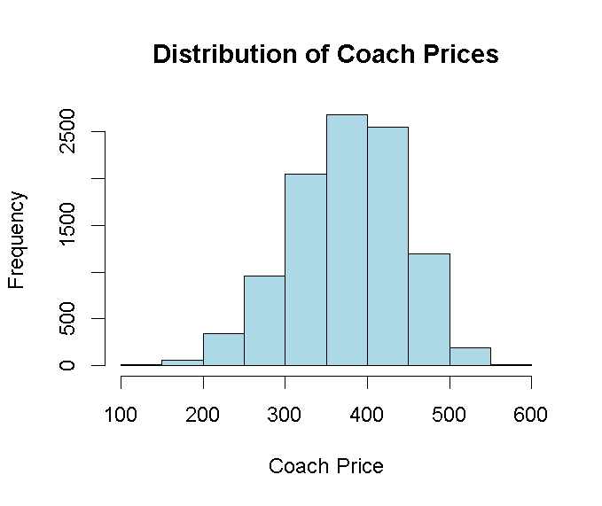

Interpretation:
- Primary Price Driver: Miles is the only statistically significant predictor in this specific model ($p < 0.001$).
- Predictive Power: This combination of distance and time explains approximately 11.8% of the variation in ticket prices.
- Data Note: The high correlation between Miles and Hours ($0.985$) means that adding "Hours" to the model doesn't provide much new information once "Miles" is already included.
6.Logistic Regression for Binary Outcomes (Redeye Flights)
R Code:
sample$redeye_binary <-ifelse(sample$redeye == "Yes", 1, 0)
log_model <- glm(redeye_binary ~ hours + miles + coach_price,data = sample,family = binomial)
summary(log_model)
hist(sample$hours,
main="Histogram of Flight Duration",
xlab="Hours",
col="lightgreen")
Python Code:
import numpy as np
sample['redeye_binary'] = np.where(sample['redeye'] == 'Yes', 1, 0)
log_model = smf.logit('redeye_binary ~ hours + miles + coach_price',data=sample).fit()
print(log_model.summary())
plt.hist(sample['hours'],
bins=30)

plt.title("Histogram of Flight Duration")
plt.xlabel("Hours")
plt.ylabel("Frequency")
plt.show()
Result:

Logistic Regression Analysis: Predicting Redeye Flights
Predictor | Estimate | Std. Error | z value | Pr(>|z|) | Significance
(Intercept) | 1.7103 | 0.2301 | 7.432 | 1.07e-13 | ***
Hours | -0.1104 | 0.1619 | -0.682 | 0.4952
Miles | 0.0006 | 0.0003 | 2.009 | 0.0445 | *
Coach Price | -0.0157 | 0.0007 | -21.369 | < 2e-16 | ***
Metric | Value
Null Deviance | 3,967.8 (on 10,032 DF)
Residual Deviance | 3,464.4 (on 10,029 DF)
AIC | 3,472.4
Fisher Iterations | 6

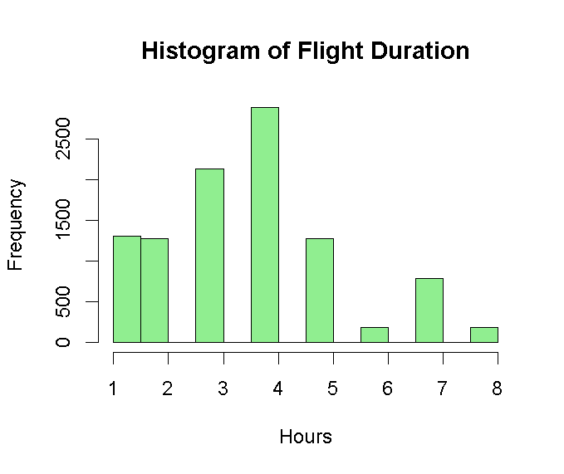

Interpretation:
Coach Price (Primary Driver): There is a highly significant negative relationship between price and redeye status ($p < 2e-16$). For every dollar increase in coach_price, the likelihood (log-odds) of the flight being a redeye decreases by approximately 0.0157. This statistically confirms the common assumption that redeye flights are priced lower than daytime flights.
Distance (Miles): The variable miles is statistically significant at the 0.05 level ($p = 0.0445$). This suggests that as the distance increases, there is a very slight increase in the probability that the flight will be scheduled as a redeye.
Flight Duration (Hours): The number of hours is not statistically significant ($p = 0.4952$). When controlling for mileage and price, the duration of the flight does not independently predict if a flight is a redeye.
Model Fit (AIC & Deviance): The model has an AIC of 3472.4. The Residual Deviance (3464.4) is lower than the Null Deviance (3967.8), which indicates that including these predictors significantly improves our ability to predict redeye flights compared to a model with no predictors at all.

